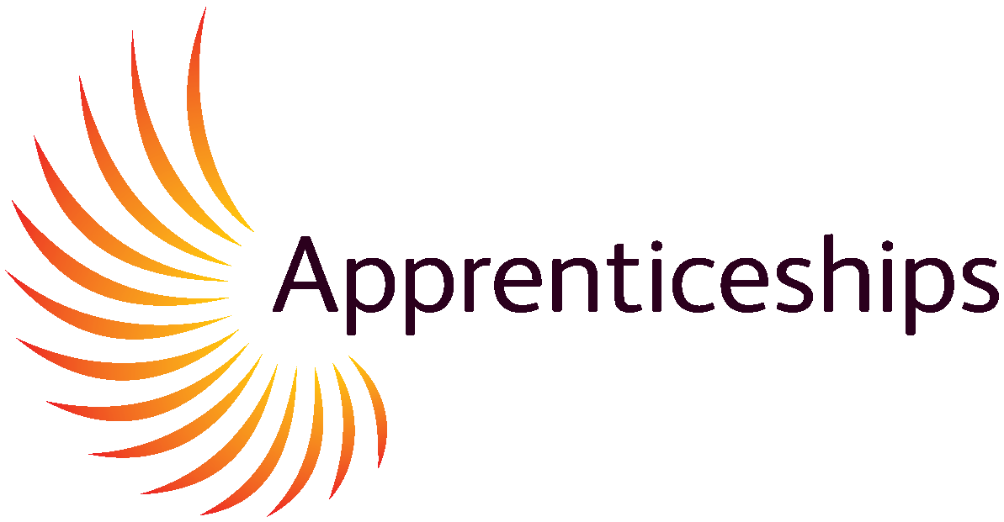
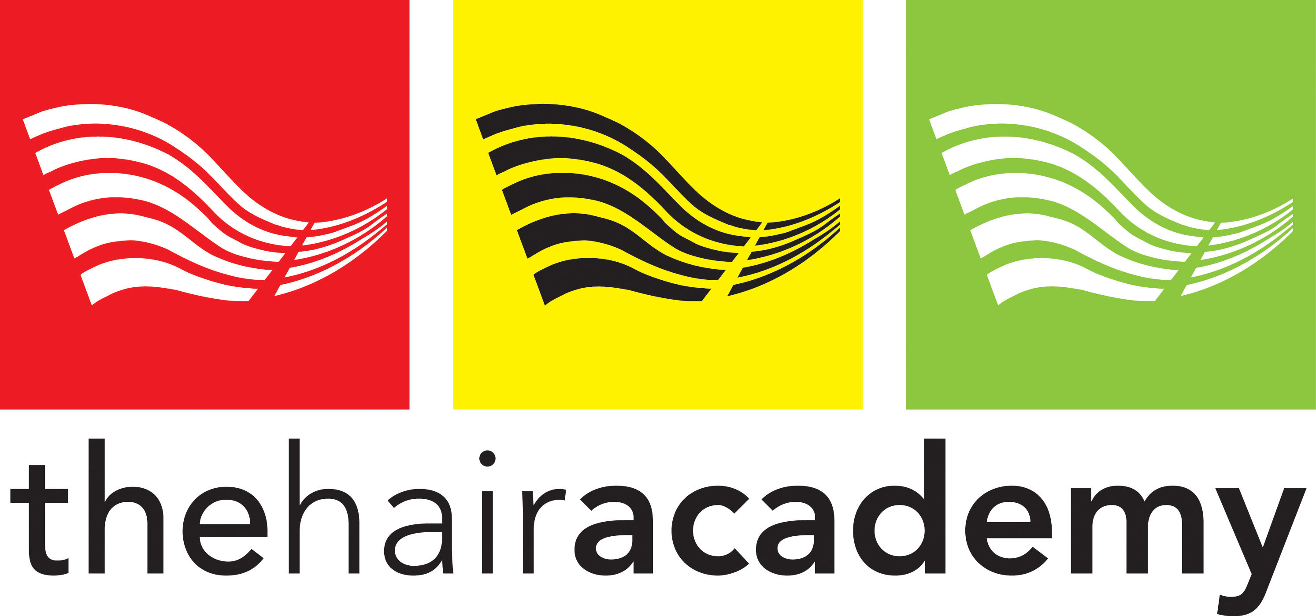

Apprenticeship Information Pack FOR LEARNERS

Are you aged 16 to 18 and looking to start an Apprenticeship?
Then why not consider The Hair Academy?

At The Hair Academy we have an enthusiastic and friendly group of Tutors that are qualified to the highest levels that are constantly improving their skills to meet your training needs effectively. We teach in small groups that ensure you receive the individual attention and support that you need to achieve your goals.

We have a well-equipped salon that is run with the support of L’Oréal education and their online training platform. We are located in Ashford town centre making it easy to get to and we have a great model base where you will work on real clients to practice your skills, with support from you designated tutor.

Using our fair and rigorous assessment process we aim to support you in becoming the best you can be within our industry. Learning using a fun and varied curriculum you will gain confidence in working with clients in a professional and safe environment.

Apprentice Qualities required to succeed
Triple A: Aspiration Attitude Achievement

What is an apprenticeship?

The Definition of an Apprenticeship

An Apprenticeship is a job that requires substantial and sustained training leading to the achievement of the apprenticeship standard and the development of transferable skills.

This definition is underpinned by four principles of future Apprenticeships.

- An Apprenticeship is a job, in a skilled occupation.
- An Apprenticeship requires substantial and sustained training lasting a minimum of 12 months normally 27-30 months, including 20% off-the-job training.
- An Apprenticeship leads to full competency in an acceptation demonstrated by the achievement of an Apprenticeship standard that is defined by Employers and Apprentices.
- An Apprenticeship develops transferable skills, including English and Maths, values/ behaviours and attitude, personal development, customer service skills, communication and confidence, as well as life skills.
What GCSE’s do I need to be eligible for an Apprenticeship?
There are currently no GCSE entry requirements for our Level 2 Apprenticeship however you will need stamina and a great sense of humour. You will also need to be creative, enjoy talking to all types of people and have ready smile. A good Apprentice is able to use their initiative be eager to learn and work well in a team. Hairdressing has previous be voted the happiest career, however it is not 9-5 job and you will be expected to work late nights and weekends.

“Hairdressing is not a job it’s a skill for a life time”

Sometimes the salon can get stressful, so it’s important to not get moody or have a negative attitude, you have to learn and be able to work with clients and staff professionally at all times, no matter what distractions there may be.

To achieve a long and happy career within the hairdressing industry you must have a flexible attitude to enable you to plan your day ahead. Being able to do so will help your organizational skills at work as well as trusting your team and help others when you can. This will show that you go the extra mile making your clients experience special and pleasant for them, as well as working as a team this will create pride in your work, a sense of achievement and above all recognition of hard work.

What will I be learning?
You will be studying toward a City & Guilds National Vocational qualification in Hairdressing or Barbering. You will learn all aspect of customer service, how to meet and greet customers, how to conduct effective client consultation, learn how to cut and colour hair and style hair in various ways. Your training will take place one day per week at the Hair Academy with your designated tutor, along with in salon training from your employer. However, learning takes place all day and every day- you will be working alongside talented hairdressers so watch and learn from your colleagues, make every moment count.

Your qualification is divided into units; the tables below represent the units that will need to be completed before you qualify for your NVQ. The green sections represent the mandatory units and the pink sections indicate the optional units that may choose from. Each unit has a credit value; you will need to achieve the required credits to achieve the full qualification your tutor will assist you with this.

Apprenticeship –
The Hair Professional Standard in level 2 Hairdressing
Cut hair using advanced techniques | Mandatory
Advise and consult with clients | Mandatory
Shampoo, condition and treat the hair and scalp | Mandatory
Colour incorporating basic colour correction | Mandatory
Style and finish hair | Mandatory
Set and dress hair | Mandatory
Cut hair using basic techniques | Mandatory
Perming | Optional
Hair extensions | Optional

Advanced Apprenticeship –
The Advanced & Creative Hair Professional Standard in Level 3 Hairdressing
Research fashion forward trends | Mandatory
Create a collection of hairstyle looks | Mandatory
Present a collection of hairstyle looks | Mandatory
Advanced and creative colour conversion | Mandatory
Smoothing & Straightening | Mandatory

To achieve an NVQ 3 in Hairdressing you must have a Level 2 qualification or
equivalent experience.

Apprenticeship –
Level 2 For Hair Professionals in Barbering
Consultation | Mandatory
Shampoo, condition & treat the hair and scalp | Mandatory
Cutting hair using barbering techniques to create a variety of looks | Mandatory
Style & Finish men’s hair | Mandatory
Cut facial hair into shape | Mandatory
Provide shaving services | Mandatory

What else will I be learning?
The apprenticeship standard dose not just focus on vocational training, there are 3 other elements that make a full Apprenticeship.

Element 1
Covering all Safeguarding, Equal Opportunity Provisions, values/behaviours and attitude, communication, customer service, personal development and employability skills which are all important elements you will need throughout your career.
Good working values and behaviours can accelerate your career and boost your client base, providing you with a loyal clientele and a long future in an amazing and exciting industry.

Element 2
You will also achieve functional skills in maths and English (if needed) Functional skills are a GCSE equivalent of an A-C grade. Apprentices are expected to take Functional Skills as part of their curriculum. If you obtained an A-C grade in your GCSE or grade 1-4 new grades, Math’s and English, you may be exempt from Functional Skills Level 1, although you will be given the opportunity to up skill to a Level 2 qualification. You must provide a copy of your GSCE certificates to qualify for an exemption.

Element 3
Once you have achieved all the above elements you will be ready to progress onto your end point assessment or EPA practical exam, professional discussion and knowledge test. This will give you the final element needed to achieve your full qualification; this will be discussed with you throughout your programme.

When you have achieved all elements of your apprenticeship programme you will achieve a nationally recognized qualification and Certificate.

What is the right level Apprenticeship for me?
At the Hair Academy we have some very exciting Apprenticeships available. These are designed for young people ages 16 to 18. The Level 2 is the Intermediate Apprenticeship (IA) and the Level 3 is the Advanced Apprenticeship (AA). These Apprenticeships are government funded and are available to young people seeking work-based learning. This allows you to achieve your qualification as well workplace experience and earn whilst you learn. The intermediate level is suitable for first time entrance to hairdressing. You do not need previous experience; you will learn all the basic aspect of hairdressing which will allow you to operate as a graduate stylist in the salon. The Advanced Apprenticeship is designed for young people that have some previous experience of hairdressing or already hold a Level 2 qualification. The Advanced Apprenticeship prepares you to further advance your creative techniques and knowledge, in order to offer more exciting services and creative looks.

The Intermediate Apprenticeship
The Level 2 Hair Professional Standard in Hairdressing

This is a National Vocational Qualification (NVQ) Level 2 in Hairdressing. This Apprenticeship will cover six subject areas. These include shampooing, consultation, Cutting, Styling, Perming and Colouring

When you have achieved all the elements of the apprenticeship standard, you will have developed the skills to work within a salon as well as gained many transferable skills.

To be eligible for this course you must be working full time in salon (30 hours a week) under a contract of employment and be paid the minimum wage for your age or above

The Advanced Apprenticeship
The Advanced and Creative Hair Professional Standard Level 3 Hairdressing

This is the National Vocational Qualification (NVQ) Level 3 in Hairdressing. This Apprenticeship will cover five subject areas. You will learn advanced Cutting & styling techniques, coloring correction methods, creating and presenting a collection of looks, hair smoothing/straightening

This qualification will enable you to work in a salon at a supervisory Level to be eligible for this course you must have an NVQ 2 in Hairdressing or equivalent experience and be working full time in the salon under contract of employment, working a minimum of 30 hours a week and be paid the minimum wage or above for your age

The Intermediate Apprenticeship
Level 2 Professional Standard in Barbering

This qualification will take place at The Hair Academy on a weekly basis with our Barbering Tutors. The training day is a Wednesday and there are two routes either the barbering unit route-suitable for those learners that have completed a level 2 in hairdressing- each unit takes 6 weeks to complete and you can choose from the below units.

Or you have the full NVQ for those with no prior experience in hairdressing/barbering

This qualification covers six subject areas to include Consultation, shampooing, Cutting using barbering techniques, styling & finishing men’s hair, cut facial hair, provide shaving services.

Level 2 hairdressing/barbering standard includes Functional Skills Math’s and English (if needed) and values and behaviors. 20% off the job training in salon and an end point assessment test

To be eligible for this course they must have a contract of employment and be working in a salon on a full-time basis 30 hours a week and be paid the minimum wage for their age or above.

What career pathways are there after doing an Apprenticeship?
Once you have completed your apprenticeship programme you will have gained valuable vocational skills that may lead you in many directions. From salons to cruise ships to theatre and film or cat walks. You will also have gained many transferable skills which will help in career changes. We will support you with your chosen or next destination route, we offer guidance throughout your course at 12 weekly reviews and beyond. If you no longer wish to stay in hairdressing or barbering then we can sign post you to one of our external partners who will further assist you to get the support towards your intended destination

A potential journey may look this.
NVQ Hairdressing standard Level 2-NVQ Barbering Level 2 - Stylist


NVQ / Diploma in Hairdressing Level 3-Barbering Level 3 – Senior Stylist,

Salon Manger or Salon Owner

Specialise as a Colour Technician / Extensions

Higher Apprenticeship level 4/5

Teaching & Assessing

Internal Verifier / External Verifier

How much will I be earning on an Apprenticeship?

Apprentices are exempt from the minimal wage for the first year of training. An apprentice currently must be paid £7.55 per hour (from April 2025) however, this is revised every April/October. Please check direct gov website for current wage information. Many Employers choose to pay more than the hourly rate in recognition of the learner’s hard work and commitment to the company.

An Apprenticeship also pays in experience, which makes you much more employable when it comes to looking for your ideal job!

What does the Employer provide for me during my Apprenticeship?
The employer will provide guaranteed training while you are on the apprenticeship programme, training may be delivered by the employer or a training provider, in the workplace or at a recognised academy. You will have a contract of employment ensuring a fair and safe working environment; you will earn a salary while you are learning not less than, but often more than, the government stated apprenticeship wage. The government review apprenticeship salaries each April/October. You will be entitled to paid holiday and bank holidays.

The Employer agrees to train you a minimum of 20% off the job training and pay you for the duration of your course, An Employer is not obliged to keep you in employment after your course has been completed but by this stage you will have the skills you need to get a job within the Hairdressing industry and we can further support you with this if you find you are not in employment after your apprenticeship ends.
Will there be a lot of homework?

You may be required to conduct research in your own time and produce assignments. You will be given targets for you to achieve both in the salon and in your training programme, it is your responsibility to maintain these targets in order for you to achieve.

Personal study time will allow you to thrive in your work.

What is the average duration of an Apprenticeship?

On average the apprenticeship duration is two years. An Apprenticeship is based on the needs of the Apprentice. Some learners can take up to 2½ years on an Apprenticeship programme, whilst others may fast track. The duration is based upon the Apprentices learning requirements, commitment & attendance and any prior learning. A year is the minimum duration of an Apprenticeship Programme.

When can I start my Apprenticeship?
Our Apprenticeships are available to start at anytime of the year.
The Hair Academy is open all year except for the last 3 weeks in December and Bank Holidays.
You will work a minimum of 30 hours in salon/barbers with your Employer and attend one day of training per week at The Hair Academy. The training hours for the hair academy are 9am – 5pm

What are the costs Involved?

There are no direct costs to you. The government will fully or match fund apprenticeship if you are under the age of 19. The Employer will be expected to pay 5% of the training charges for any learner aged 19+ at the date of apprenticeship sign up, apprentices are not expected to pay for training. However, you may need to buy some personal equipment such as scissors, your employer will tell you what you will need to provide at your salon/barber interview.

What transport funding is available, if so, how do I apply?

Unfortunately, funding for travel is unavailable. Although, the government do offer some financial support for transport but this depends on your personal circumstances and your household income.

NUS Apprenticeship cards…now known as TOTUM Apprentice

NUS cards are now available for Apprentices at a small cost. This entitles you to receive up to 20% discounts in many high street shops and restaurants.

For more information on NUS Cards, visit the website below where you can purchase your card and start saving!

http://www.totum.com

What happens if you are absent from your work place or The Hair Academy?

If you know that you are going to be absent or late, you must inform The Hair Academy as well as your Employer. A text message is NOT a satisfactory form of communication of an absent Learner.

You must tell The Hair Academy before 8.30am that morning. The Hair Academy will contact your Employer to inform them of your absence. Training days are valuable, too many absences may reduce the likelihood of qualifying for your course

Is additional support and guidance available for learners with special needs?

During the enrolment process an Initial Assessment is carried out for each Learner to identify any special learning requirements that you may have.

If you have any special learning requirements, they will be supported with Basic Skills Training at The Hair Academy.

If you are identified with special Learning needs The Hair Academy may refer you to an outside source for support.

What is The Hair Academy Learner’s Agreement?

Our Learner’s Agreement is a contract between The Hair Academy, your Employer and the you. Everyone involved has to sign agreeing their commitment in regards to the apprenticeship.

The Employer also has to sign a Definition of a Quality Apprenticeship Agreement, commitment statement and a training plan. These documents identifying the Employer’s commitment and responsibilities to you during your time of employment on your Apprenticeship.

Do I have to wear a uniform?

While you are in the academy you will be required to wear suitable footwear (must be closed toes) and plain black or white clothing. You will not be permitted to attend to a client if you are not in uniform and may be returned to the salon. You will be supplied with a lanyard and you will be expected to wear it during every visit to the academy.

Learners must follow the academy code of conduct at all times and wear the correct uniform

- Have your work file available for all training sessions
- Have the necessary tools and equipment to perform both theory and practical tasks
- Males must be clean shaven or with groomed facial hair
- Females’ hair must be clean and styled in a manner that reflects the industry. Pony tails are not permitted, unless styled to reflect industry
- Make-up if worn, should be maintained throughout the day
- Nails are to be clean, if polish is worn it must not be chipped or peeling off. If Gels, tips, or acrylics are worn they must be a suitable length for you to perform all your services

The Hair Academy does not permit the following

- Faded Jeans – ripped, torn, stone washed or stained-very smart black only
- Scruffy, dirty or unsuitable footwear i.e., stilettos, flip flips, sliders, mules, trainers, croc’s etc…it is for your own safety
- Excessive jewelry
- Chewing gum whilst with clients
- Mobile phone usage or charging whilst on premises
- Smoking/vaping on the premises or within site of the building

Please see full academy code of conduct and dress code

What do I need to bring when I start my Apprenticeship?


Scissors
All equipment is required from all Apprentices before starting.

The Hair Academy will supply a lanyard that must be worn at all times whilst at The Hair Academy.

If the lanyard is lost, a replacement cost will be included.

Replacement is £2.00
Clips
Combs
Pencils
Pens
Notepad
Plastic Wallets

How do I apply for The Hair Academy Apprenticeship programme?

For you to be apart of an apprenticeship, you must have a general contract of employment with one of our many salon partners. We can support with finding a salon if you do not currently have a salon placement

It is then the employer’s responsibility to inform us and together we will enroll you upon an apprenticeship that meets your academic requirements.

We also offer taster days so you can come in for the day and see what it is like before you commit to an apprenticeship with your employer.

I don’t live with my parents; how does this affect my benefits?
As you will be working and earning during your Apprenticeship, some benefits can be affected. As your income will change, your rate of benefit will to. If you are concerned about your income changes contact the relevant departments for further information.

It is also important that you don’t forget to declare any changes to your income to the relevant sections below

Tax Credits: Job Centre Plus:
Housing Benefit: DWP:

When is The Hair Academy open?
Monday – Thursday 09:00am – 17:00pm

Our Academy is open all year except the last 3 weeks in December and Bank Holidays

How do I get to The Hair Academy?

By Train
Ashford International Station is a 5-minute walk away from the academy

By Road
Ashford – M20 junction 9 or 10, follow signs for the town center and aim for the church in the center of town. Parking available in all car parks including: - behind the Hollywood Bowl, Vicarage Lane etc. Postcode = TN23 1QG

How do I contact The Hair academy and who do I speak to?
If you have read this Information Pack and believe that this is the perfect opportunity for you to gain the qualifications that you will need to succeed in a professional career in Hairdressing/barbering, then contact Kay Hopkins the Training Manger or Jo Dawes our administration Manger. Alternatively, you can pop in to chat to us in the academy or check out our website www.thehairacademy.co.uk

We look forward to meeting you and supporting you onto your chosen career pathway


Ashford academy
The Clergy House Phone: 01233 660990
The Churchyard
Ashford
Kent
TN23 1QG

Email: info@thehairacademy.co.uk

www.thehairacademy.co.uk

