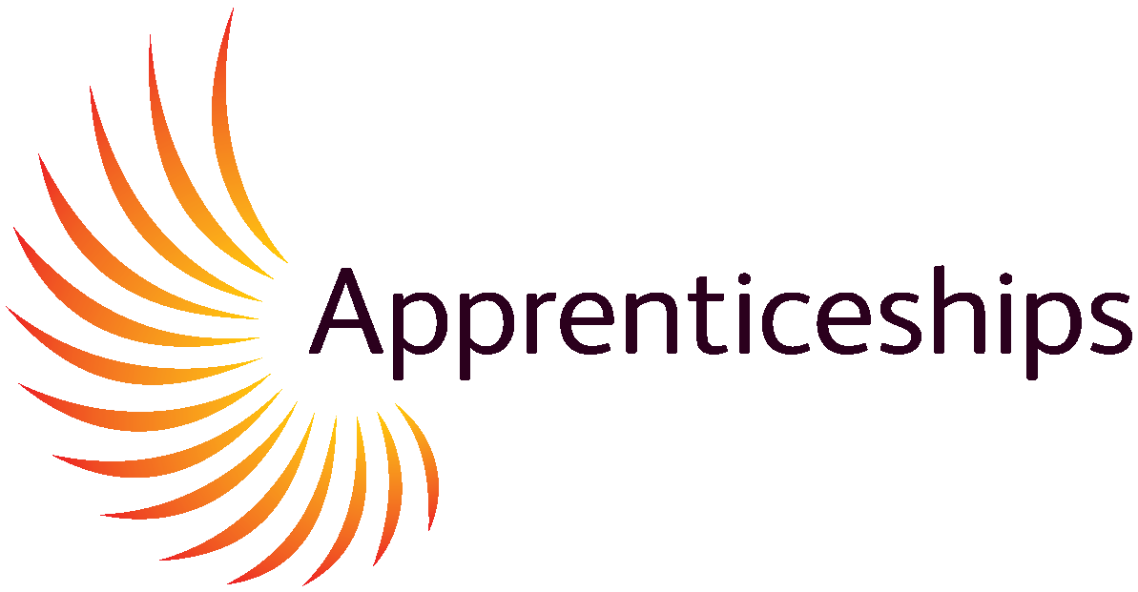
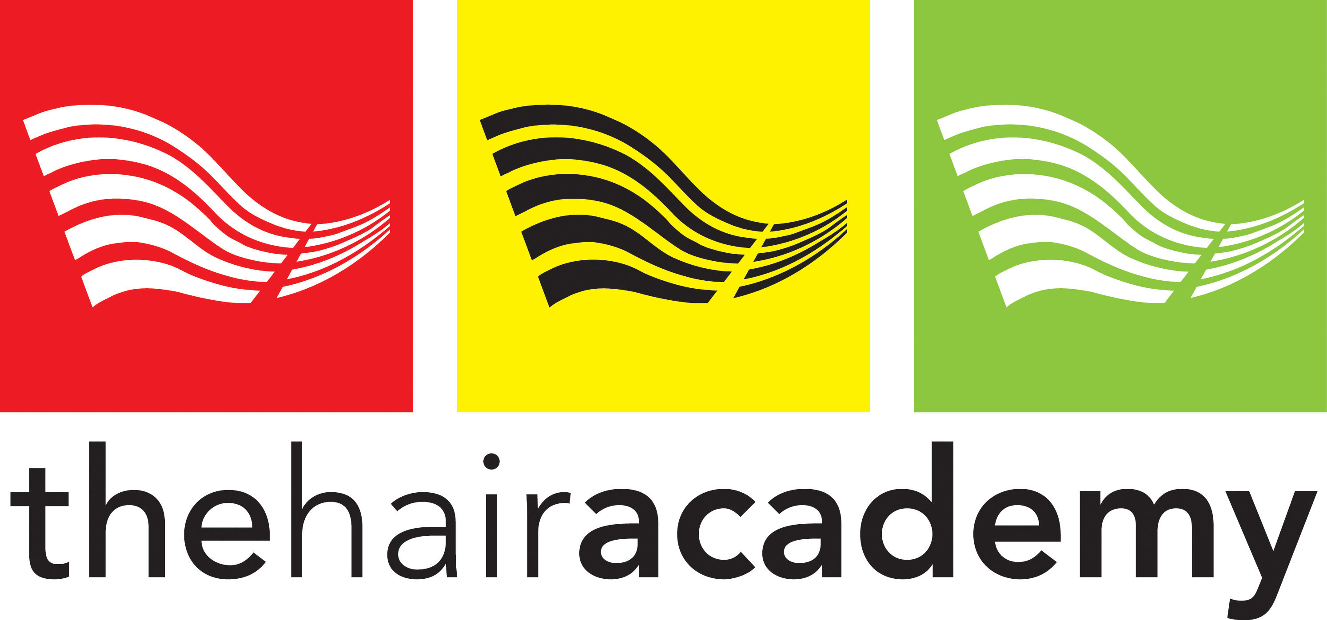

Apprenticeship Information Pack - FOR EMPLOYERS

Who are we?

At the Hair Academy we have an enthusiastic and friendly group of Tutors that are qualified to the highest levels and are constantly improving their skills to meet the Learners training needs effectively. We teach our Learners in small groups, to ensure that they have the attention and support that they need.

Your learner will work in a well-equipped salon which is supported by L’Oréal.
Our Tutors teach above the National Standards to enable your Learner to achieve the necessary skills to work on the salon floor as a Stylist. Using our rigorous assessment process, we aim to support them in becoming the best they can be within our industry. They will gain confidence in working with clients in a professional and friendly environment.

The Hair Academy is open all year except the last 3 weeks in December and all bank holidays. Further information can be found on our website www.thehairacademy.co.uk

This Information Pack will give you the information that you need for employing a future learner onto our Apprenticeship programmes.

Apprentice Qualities required to succeed
Triple A: Aspiration Attitude Achievement

The Definition of an Apprenticeship

An Apprenticeship is a job that requires substantial and sustained training leading to the achievement of the apprenticeship standard and the development of transferable skills.

This definition is underpinned by four principles of future Apprenticeships.

- An Apprenticeship is a job, in a skilled occupation.
- An Apprenticeship requires substantial and sustained training lasting a minimum of 12 months, normally 2-2.5 years, including 20% off-the-job training.
- An Apprenticeship leads to full competency in an acceptation demonstrated by the achievement of an Apprenticeship standard that is defined by Employers and Apprentices.
- An Apprenticeship develops transferable skills, including English and Maths (where needed) customer service skills, communication, personal development and confidence, as well as time keeping, team work and the correct attitudes and behaviours in the work place.

Which Hairdressing Apprenticeships are available at
The Hair Academy?

Here at The Hair Academy, we offer a fun and varied curriculum designed for people aged 16 – 24. The Level 2 is the Intermediate Apprenticeship (IA) and the Level 3 is the Advanced Apprenticeship (AA). These Apprenticeships are government funded and are available to young people looking for work-based learning. This allows them to earn whilst they learn, the duration of an Apprenticeship is on average two years, but this will be agreed with you and The Hair Academy during the Induction Process.

The Intermediate Apprenticeships in Hairdressing
Level 2 Hair Professional Standard

Hairdressing Standard Units
This is a National Vocational Qualification (NVQ) Level 2 in Hairdressing. This Apprenticeship will cover 6 subject areas. These include Consultation, Shampoo and condition, Cutting, Styling and dressing hair, Perming and Colouring. Math’s & English (if needed) Values, behaviors and attitude, 20% off the job training in salon and an end point assessment (EPA)

Once they are qualified to a Level 2, they would have developed the skills to work within a salon as well as gaining many employability skills.

To be eligible for this course they must have a contract of employment and be working in a salon on a full-time basis. Minimum of 30 hours a week and be paid the minimum wage for their age.

Training is 1 day a week at the hair academy
Training day will be discussed with you

The Advanced & Creative Hair Professional Apprenticeship Standard in Level 3 hairdressing

This is a National Vocational Qualification (NVQ) Level 3 in Hairdressing. This Apprenticeship will cover six subject areas. Some of these areas are Advanced Cutting & Styling techniques, promotional activities, color conversion methods, smoothing & straightening as well as photographic and hair collections.

This qualification will enable them to work in a salon at a Supervisory/senior Level.

To be eligible for this course the learner must have completed an NVQ Level 2 in Hairdressing or equivalent experience, be working under a contract of employment in a salon on a full-time basis

Training is 1 day a week at the hair academy, training day will be discussed with you.

Level 2 Diploma for Hair Professionals in Barbering

This qualification will take place at The Hair Academy on a weekly basis with our Barbering Tutors. The training day is a Wednesday and there are two routes either the barbering unit route-suitable for those learners that have completed a level 2 in hairdressing- each unit takes 6 weeks to complete and you can choose from the below units.

Or you have the full NVQ for those with no prior experience in hairdressing/barbering

This qualification covers six subject areas to include Consultation, shampooing, Cutting using barbering techniques, styling & finishing men’s hair, cut facial hair, provide shaving services.

Level 2 hairdressing/barbering standard includes Functional Skills Math’s and English (if needed) and values and behaviors. 20% off the job training in salon and an end point assessment test

To be eligible for this course they must have a contract of employment and be working in a salon on a full-time basis 30 hours a week and be paid the minimum wage for their age or above.

Additional Courses and Qualification available at The Hair Academy

- Barbering Units – individual Units at a cost of £500 each
- Barbering full NVQ- self funded £3000
- HeadSTART- Daily Training £50.00 per day
- NewSTART- Self funded Level 2 diploma in hairdressing-£4000
- Hairdressing Level 3 diploma-Self funded- £5000
All prices include VAT

What is The Hair Academy / Employer/ Leaner’s Agreement?

Our Learner’s Agreement is a contract between The Hair Academy, the Employer and the Learner. Everyone involved will sign to agree their roles and responsibilities in regard to the apprenticeship. Employer will be issued with a Definition of a Quality Apprenticeship Agreement. This document indentifies the employer’s responsibilities to the learner during their time of employment on their Apprenticeship.

You are responsible for covering and supporting with the following,

Covering Safeguarding, Equal Opportunity Provisions, Work hours and Annual Leave, Training Nights, Salon Code of Conduct, Working Time Regulations / Minimum Wage, Sickness Absence and Sick Pay, Employee Rights – Contract of Employment, Organisations within Hairdressing, Health and Safety, Grievance Procedure, Disciplinary Procedure and Advice, Issue of Public Concern, Career Pathways and Progression Routes and Advice and Maternity Rights & Pay. 20% off the job training in salon (6 hours per week)

What do I have to pay an Apprentice?
Apprentices are exempt from the minimal wage for the first year of training. An apprentice currently must be paid £7.55 per hour however, this is usually revised every April. (Please visit www.gov.uk for more information & guidance) Many Employers choose to pay more than the hourly rate in recognition of the learner’s hard work and commitment to the company. Alternatively, you can visit www.gov.uk online and that will have the latest National minimum wage information and guidance on Employing an Apprentice.

Is there any help to employ an apprentice?
The Government offer an incentive payment for learners on the new hairdressing Standard of £1000, this is paid over two payments at start up (after 3 months and after 12 months) Please contact us for up-to-date information on this.

What does the learner need to bring when they start their Apprenticeship?


Scissors
All of the equipment is required from all Apprentices before starting.

The Hair Academy will supply a complimentary lanyard that must be worn at all times whilst at The Hair Academy.
If this gets lost, a replacement cost will be included.

Replacement £2.00
Clips
Combs
Pencils
Pens
Notepad
Plastic Wallets

How will I know how my learner is progressing?

The Hair Academy will send you a formal assessment plan every 3 months after a review has been completed, stating what the learner has been working on in training sessions and what they have achieved. There are also new targets set for the learner to follow and employers are encouraged to support in salon with the targets set. Your learner’s progress is at the heart of all our decisions therefore it is vital that we maintain effective communication.

Can I attend the academy to see how my learner is doing?

You can visit us at any time to observe your learner in training, no appointment necessary. We are more than happy to hold meetings in person with you throughout the year to provide you with updates on changes that may affect Apprenticeships, (this information will also be sent via email and newsletters) as well and provide you with an opportunity to meet with our tutors and discuss your learner progress; we welcome your views and invite your opinions on how we may improve our service offer to further develop our training programmes. “The Hair Academy team teach above the standards and asses to the standards “

Can I assess my learner in the work place?

Yes, we encourage employers and in-house assessors to participate in the learning process. You may record your learner’s progress in the formative logbook and if you hold an Assessor Award you may also conduct summative assessment which may be recorded in your learners E portfolio. Assessors that conduct summative assessment must comply with the City and Guilds quality assurance procedures and attend at least two annual standardisation meetings and provide evidence of the required hours of continuous personal development (CPD) per year. Tutors are also subject to quality assurance visit from internal and external verifiers.

Are there any costs that I have to pay?

A Level 2 apprenticeship age16-18 has no employer costs it is 100% Government funded.

Employers have to open an apprenticeship service account to secure funding for the apprentice and select the provider they wish to place their apprentice with.

Please note that any learners over the age of 19 will attract a 5% employer contribution to training, this covers both the Level 2 and Level 3 qualifications


For further details see our website: www.thehairacademy.co.uk or follow us on face book and twitter.

Employers may use this Crib Sheet during the Interviewing process. This will help you to identify key aspects of the job role and it will also simplify the process for the learner.

Crib Sheet

Employers contact Details:

Job roles and responsibilities:

Uniform/Dress code: | Code of behaviour:
Days of work: | Late Nights:
Day off: | Salon Equipment needed:
Team meetings:
Time:
Location:

Training Days & location: | Training Evenings & location:
Salary: | Travel expenses;
Holiday Entitlement: | Holiday Pay:
Payment Process:  Account details | Sickness Pay:

