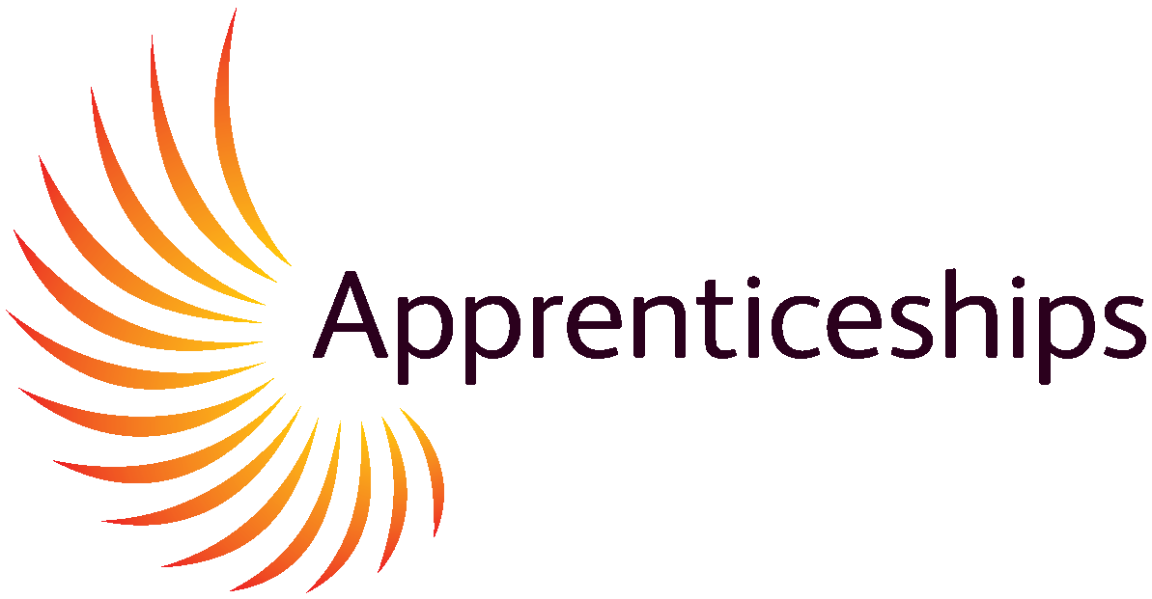
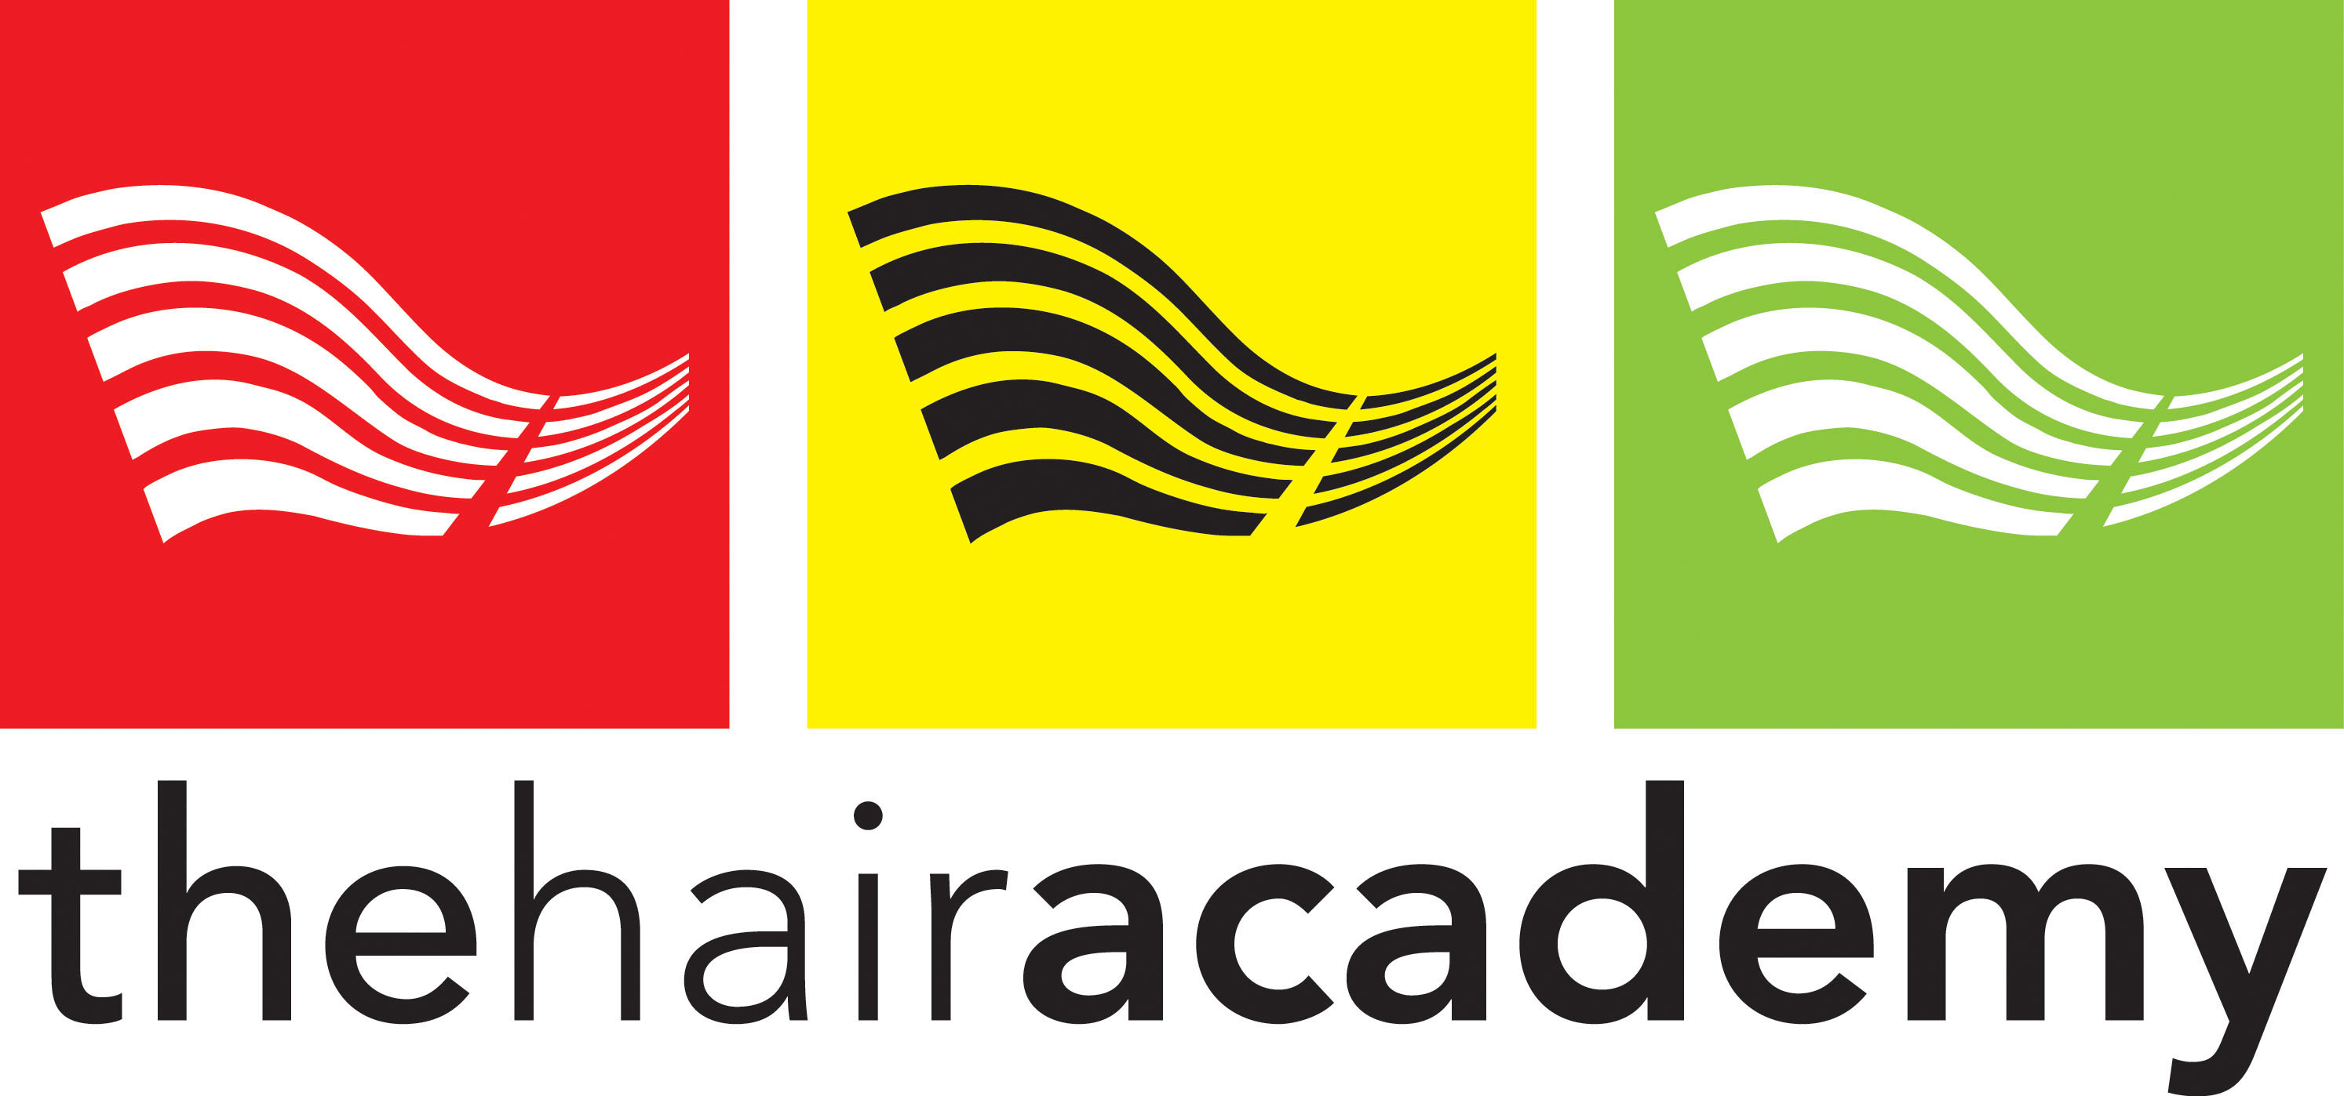
Apprenticeship Information Pack - FOR PARENTS

Is your child aged 16 to 24 and looking to start an Apprenticeship in hairdressing or barbering? Then why not consider The Hair Academy?

At The Hair Academy we have an enthusiastic and friendly group of Tutors that are qualified to the highest levels that constantly improving their skills to meet the Learners training needs effectively. We teach in small groups that ensure Learners receive the individual attention and support they need to achieve.

We have a well-equipped salon that is run with support from L’Oréal. The Learner will work in a commercial salon environment, working with clients whilst being supported by our Tutors. Using our rigorous assessment process, we aim to support Learners in becoming the best they can be within our industry. Learning from a Fun and varied curriculum they will gain confidence in working with clients in a professional and safe environment.

The Hair Academy is open all year except the last 3 weeks in December and Bank Holidays.
Further information can be found on our website www.thehairacademy.co.uk.

Apprentice Qualities required to succeed.
Triple A: Aspiration Attitude Achievement

The Definition of an Apprenticeship

An Apprenticeship is a job that requires substantial and sustained training leading to the achievement of the apprenticeship standard and the development of transferable skills.

This definition is underpinned by four principles of future Apprenticeships.

- An Apprenticeship is a job, in a skilled occupation.
- An Apprenticeship requires substantial and sustained training lasting a minimum of 12 months normally 2.5 years, including 20% off-the-job training.
- An Apprenticeship leads to full competency in an acceptation demonstrated by the achievement of an Apprenticeship standard that is defined by employers and apprentices.
- An apprenticeship develops transferable skills, including English and Maths, customer service skills, communication, personal development, and confidence.

Frequently asked questions from parents include: -

Which hairdressing Apprenticeships are available at The Hair Academy?

Here at The Hair Academy, we have some very exciting Apprenticeships available. These are designed for young people ages 16 to 24. The Level 2 is the Intermediate Apprenticeship (IA), and the Level 3 is the Advanced Apprenticeship (AA). Apprenticeships are government funded and are available to young people looking for work-based learning. Apprentices are employed full time under a contract of employment at the employer’s premises.

This allows them to achieve their qualification as well as having workplace experience and a salary whilst learning.

The Intermediate Apprenticeship the
Hair Professional Standard in Level 2 Hairdressing

This is a National Vocational Qualification (NVQ) Level 2 in Hairdressing. This Apprenticeship will cover 6 subject areas. These include consultation, shampooing, Cutting, Styling, Colouring and perming

Level 2 hairdressing standard includes Functional Skills Math’s and English (if needed) and values and behaviors. 20% off the job training in salon and an end point assessment test

Once they are qualified to a NVQ 2 Level, they would have developed the skills to work within a salon as well as gaining many employable skills.

To be eligible for this course they must have a contract of employment and be working in a salon on a full-time basis, 30 hours a week.

The Advanced & Creative
Hair Professional Apprenticeship Standard in Level 3 hairdressing

This is a National Vocational Qualification (NVQ) Level 3 in Hairdressing. This Apprenticeship will cover six subject areas. Some of these areas are Advanced Cutting & Styling techniques, promotional activities, color conversion methods, smoothing & straightening as well as photographic and hair collections.

This qualification will enable them to work in a salon at a Supervisory/senior Level.
To be eligible for this course they must have their NVQ 2 in Hairdressing or equivalent experience. They will also need to be working fulltime in a salon under a contract of employment.

Apprenticeships Level 2 Diploma for
Hair Professional in Barbering

This qualification will take place at The Hair Academy on a weekly basis with our Barbering Tutors.
This qualification covers six subject areas to include Consultation, shampooing, Cutting using barbering techniques, styling & finishing men’s hair, cut facial hair, provide shaving services.
Level 2 hairdressing/barbering standard includes Functional Skills Math’s and English (if needed) and values and behaviors. 20% off the job training in salon and an end point assessment test

To be eligible for this course they must have a contract of employment and be working in a salon on a full-time basis, 30 hours a week.

Additional Courses and Qualification available at The Hair Academy
- Barbering Units – individual Units at a cost of £500 per unit
- Barbering full NVQ- self funded £3000
- HeadSTART- Daily Training £50.00 per day
- NewSTART- Self funded Level 2 diploma in hairdressing- £4000
- Level 3-self funded advanced hairdressing diploma £5000
All prices include VAT

What GCSE level does my child need to have to be eligible for an Apprenticeship?

There are currently no entry requirements for our Apprenticeship programme. Learners will be expected to be able to take initiative without instruction, have good social skills, be willing to work some late nights and weekends. They are also expected to be creative, have good team working skills, a ready smile and a good sense of humour and be eager to learn now skills.

How much will they earn on an Apprenticeship programme?

The minimum wage for an apprentice is £7.55 per hour. This rate is usually reviewed each April. Although, this can vary as the Employer may choose to pay a higher rate of wage. (Please see direct gov website for up-to-date information)

What transport funding is available, if so, how do I apply?

Unfortunately, funding for travel is unavailable, although the government do provide funding for transport depending on your personal circumstances and household income. Individual employers may choose to help with the cost of their travel although they are not obligated to.

Are Functional Skills a part of the apprenticeship programme curriculum?

Functional skills are a GCSE equivalent of an A-C grade. Apprentices are expected to take Functional Skills as part of their curriculum. If they obtained an A-C or the new 1-4 grade in their GCSE Math’s and English, they may be exempt from Functional Skills Level 1, although they will be given the opportunity to up skill to a Level 2 qualification.

What are the costs involved?

There are no costs to you as a parent/guardian.
All apprenticeships ages 16-19 are fully funded by the Government.

What is the progression route of an Apprentice?

NVQ Hairdressing standard Level 2 - Stylist


NVQ Advanced & Creative Hair Professional Level 3 – Senior Stylist, Salon Manger, or Salon Owner

Specialise as a Colour Technician / Extensions

Train and became a Tutor.

Internal Verifier

External verifier (City and Guilds)

There are a lot of options to consider, and we can support you and your child to get to where they want to be, we can also sign post you to our partners who offer further careers advise if they do not want to stay within the industry.

What will Apprentices be expected to complete?

Research assignments are expected when needed and they will be responsible for the upkeep of their work in their personal time. They will also need to update their work file portfolio on a daily/weekly basis.

Personal study time will allow them to thrive in their work.

What is the average duration of an Apprenticeship?

On average the apprenticeship duration is two years. An apprenticeship is based on the needs of the apprentice. Some learners can take up to 3 years on an Apprenticeship programme, whilst others may fast track. The duration is based upon the Apprentices learning requirements. A year is the minimum duration of an Apprenticeship Programme.

Our Apprenticeships are available to start at anytime of the year.

What does The Hair Academy Learner’s Agreement include?

Our Learner’s Agreement is a contract of all parties of an Apprenticeship. The Hair Academy, the Employer and the Learner sign agreeing to their responsibilities in regard to the Apprenticeship Programme. May also be known as the commitment statement.

The Employer also has to sign a Definition of a Quality Apprenticeship document/commitment statement. This is a document specifying the Employer’s duties and responsibilities to the Apprentice during the duration of employment on the programme.

What does the Employer provide for them during their Apprenticeship?

The Employer is responsible as well as The Hair Academy to offer training and experience in order for them to gain the skills they need to enhance the future progression in a career of Hairdressing.

The Apprentice will work a minimum of 30 hours with their Employer and off the job training hours must be recorded and carried out in the salon, roughly 6 hours a week. Training is carried out in the academy 1 day a week.

The Employer agrees to work with and pay the Apprentice for the duration of their course. An Employer is not obliged to keep the Apprentice in employment after their course has been completed.

What happens if they are absent from their workplace or The Hair Academy?

If you know that the Learner is going to be absent or late, communications must be made. A text message is not satisfactory notice of an absent Learner. This applies for The Hair Academy as well as in the workplace.

Notice must be given before 8.30am that morning. If notice is not given, The Hair Academy will contact the Employer to inform them of the absence. This also a precaution and for safeguarding purposes.

Training days are valuable, too many absents may reduce the likelihood of the learner succeeding in the programme.

What will my child need to bring to their Apprenticeship?

All of the equipment is required by all Learners before starting the apprenticeship programme.

The Hair Academy will supply a complimentary lanyard that must be worn at all times whilst at The Hair Academy.

If lost a new on will need to be obtained from Jo in the office and a small cost may be incurred.

Scissors

Clips

Combs

Pencils

Notepad

Pens

Plastic wallets

Does the Apprentice have to wear a uniform?

Yes, your child will be representing The Hair Academy and will be expected to wear the correct attire and follow the academy dress code, black trousers, skirts, dresses, shirts, T-shirts, and suitable black footwear. The Hair Academy DOES NOT PERMIT the following.

- Jeans, unless they are very black and smart.
- Trainers- unless plain black or white, stilettos, sliders, flip flops, coloured footwear
- Thong sandals
- Excessive jewelry
- Learners chewing gum whilst with clients.
- Mobile phone usage whilst on premises unless it is for academy work.
- Smoking/vaping on the premises or within site of the building

Learners are required to: -

- Have their work file, scissors, and combs available at all training sessions.
- Gentlemen must be clean shaven or with groomed facial hair.
- Hair must be clean and styled in a manner that reflects the industry. Ponytails are not permitted unless styled.
- If make-up is worn it must be maintained throughout the day.

Is additional support and guidance available for Learners with Special Needs?

During the enrolment process an Initial Assessment is carried out for each Learner to identify any special learning requirements that your child may have.

If a Learner has any special learning requirements, they will be supported with Basic Skills Training at The Hair Academy.

If a Learner is identified with special Learning needs The Hair Academy may refer them to an outside source for support.

If my child enrolled onto an Apprenticeship Programme, does that affect my benefits?

As the Learner is earning a wage it may affect your rate of your benefit. This is due to the change in your household income. If you are concerned about this, contact the relevant departments for further information.

It is also important that you don’t forget to declare any changes to your income to the relevant sections.

Tax Credits: Job Centre Plus:
Housing Benefit: DWP:

How do they apply for The Hair Academy Apprenticeship?

For an Apprentice to become part of our apprenticeship programme they must have a Contract of Employment. It is then the Employer’s obligation to inform us and together we will enroll them for an Apprenticeship that meets their academic requirements and needs. If a salon placement is needed, we can also support with this through our salon partners.

How do I contact The Hair Academy and who do I speak to?

If you have read this Information Pack and believe that this is the perfect opportunity for your child to gain the qualifications that they will need to succeed in a professional career in Hairdressing or barbering, then contact Kay Hopkins the Training Manager or Jo Dawes our administration manager, they can offer more insight into the Apprenticeship Programme.

Alternatively pop in for a coffee and a chat to discuss further, appointments are not always necessary.

Address: The Clergy House Telephone: 01233 660990

The Churchyard
Ashford
Kent
TN23 1QG

Web Address: http://www.thehairacademy.co.uk

